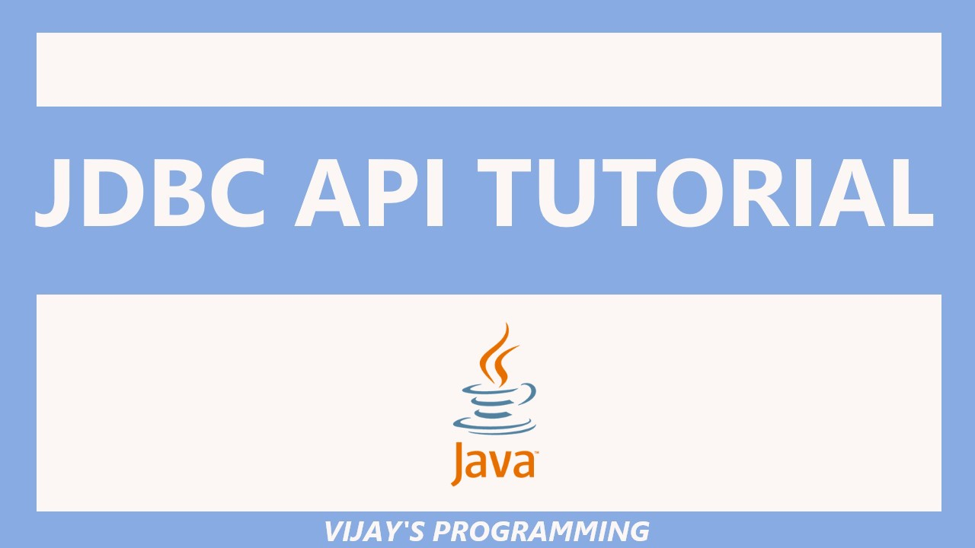

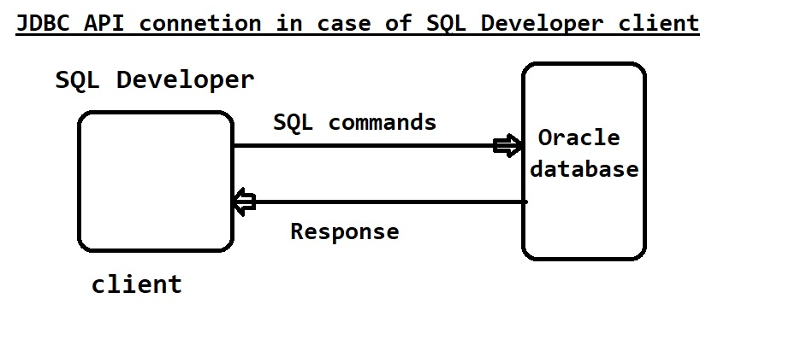

🡺SQL Developer completely written in Java.

🡺Even SQL Developer also uses JDBC concept to interact with the database. And our java program also need to use the JDBC concept to send SQL commands to the database.

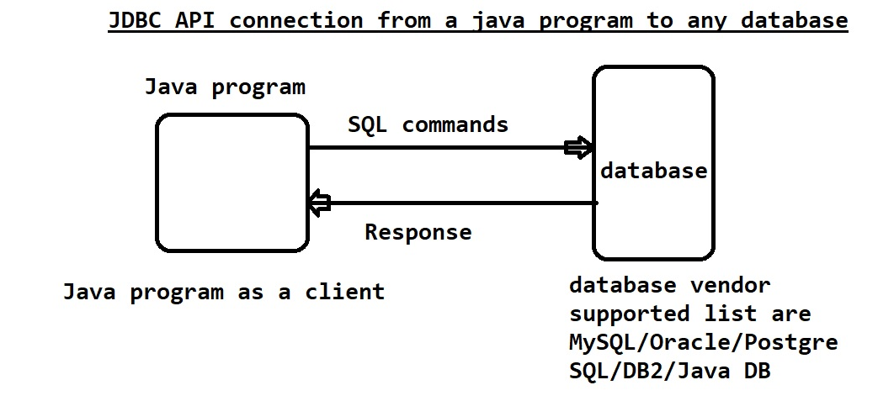

**How to write a similar code that interact with the database?**

🡺From a java Program to interact with a database to send SQL commands to the database and to interact with the database, we need JDBC concept.

🡺To establish a connection from java program to the database there is concept called driver.

* Driver is used for establishing a connection from java program to the database.
* Without Driver we can’t make a connection from java program to the database.
* SQL Developer has a built in driver using that driver it is making a connection to the database.

🡺JDBC is a API. It’s a kind of library having several classes and interfaces combining all this things JDBC API is developed.

🡺without JDBC we cant interact with the database. In case of Java based program definitely JDBC is required to interact with the database.

🡺JDBC is available in the JDK itself. We don’t need to download and install it separately.

🡺inside JDK installation there are two packages containing JDBC API. I,e

1. java.sql

2. javax.sql .

These two packages are available in Java Runtime Environment(rt.jar). this rt.jar contains **java.lang, java.io, java.util** packages similarly **java.sql and javax.sql** as well. As a beginner we are mainly focusing on **java.sql** package.

🡺important members of java.sql

1. DriverManager(C)
2. SQLException(C)
3. Connection(I)
4. Statement(I)
5. ResultSet(I)

🡺java.sql and javax.sql packages does not contains the driver. Driver is not available in rt.jar, in the JDK installtion Driver is not there. SQL Develope has in-built Driver Our java program as well need a Driver to establish a connection to the database. **We dont have Driver itself in the JDBC API but we have classes and interfaces which are managing driver.**

🡺JDBC has a dependency of the Driver. While installing Oracle Database it will be installing Driver. Driver is almost dependent on Database. Oracle Driver cant be used in the MySql interaction and MySql Driver cant be used in the Oracle interaction. Driver is database specific. Database vendor only has provide the Driver. And that Driver management classes and interfaces available in the JDBC API but not the Driver itself.

🡺Where is Driver available with respect to Oracle Database?

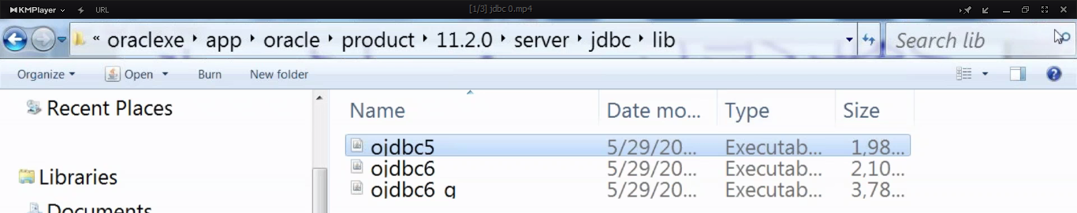

“ojdbc5” this is the JAR file that contains Driver class.

In all these three JAR files Driver Class is available. we have to use any one JAR file.

🡺to extract jar file use D:\Developmentsoftwares\oraclexe\app\oracle\product\11.2.0\server\jdbc\lib>jar xf ojdbc5.jar

🡺To see the exact Driver class inside ojdbc5 extract it to a folder and go to this path.

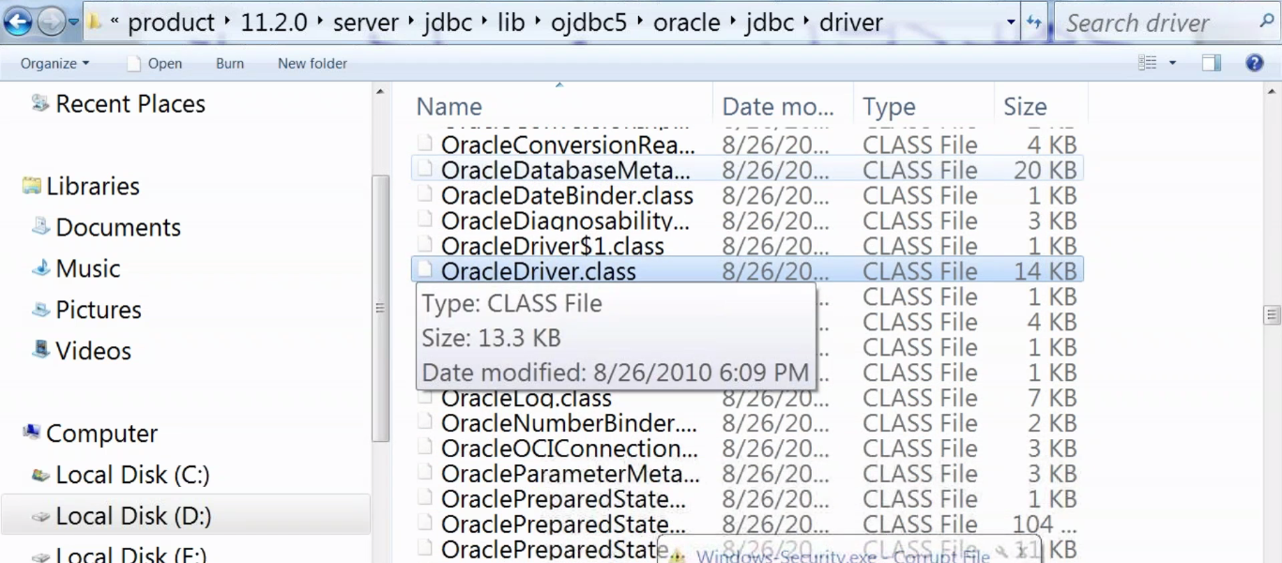

🡺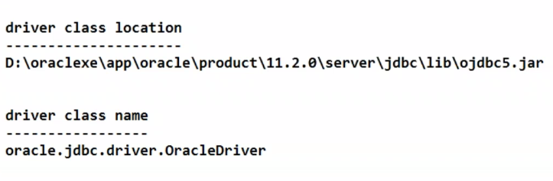

🡺javac and java commands are not aware of the JAR files which are outside JDK installation.

So this JAR files and its contents comes under third party tools. Any third party classes location should be updated to javac and java command.

🡺How to update JAR file location to java and javac command?



We need to update it in the class path. Importance of “.” In the classpath, because of “.” Only java command will be considering current directory class files. “.” Represents current directory. We need to update this class path under environment variable.

Copy the path and update under user level.

🡺To check for the class path updating sucess..open new command prompt window

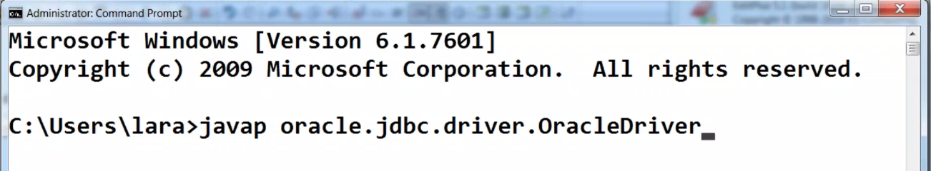

Another way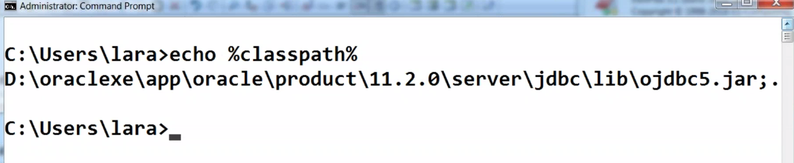%classpath% can be in any case.

**JDBC Procedure**

1. Load and register driver.
2. Establish the connection between the Java application and the database.
3. Creation of statement object
4. Send and execute the SQL query
5. Process results from result set.
6. Close the connection.

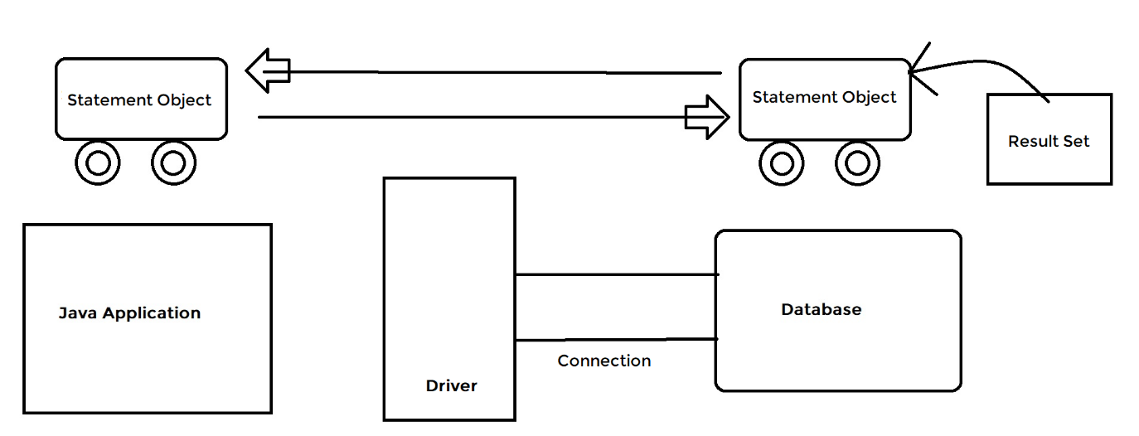

1. **Java Application:**

Java Application requires data from the database but the problem is it doesn’t know the SQL.

1. **Database**

Database doesn’t know the Java.

1. **Driver**

To convert from Java To SQL and SQL to Java Translator.

1. **Connection (network socket)**

To reach the database.

1. **Statement Object**

To send a request and bring the result. Statement Object is having the result set.

1. **Result Set**

The results from database .sql query result from the SQL.